

Faculty of Computer Applications
BCA Sem-1
(AY-2026-27)

Lab Book

Sub Code: 05BC3103
(Programming Practices: 1)

Roll No : | Shashikant Kumar
Full Name : | 92600527058

GitHub Link |

Sub. Faculty Name
Prof. Vipulkumar Bambhaniya
Index

Unit : 1
Program No | Definition
Draw Algorithm and Flow chart for the following
Definitions
1 | Print “Hello World”.
2 | Takes 2 Values from user and Perform All Arithmetic Operations.
3 | Print numbers from 1 to 20.
4 | Input 3 values from user and find out its Average.
5 | Calculate the Square and Cube of a number.
6 | Interchange the value of two numbers.
7 | Find largest out of three numbers
8 | Find out Fibonacci series up to given n values
9 | Find out Number is Odd or Even
10 | Find out sum of digits of a given number.
Unit : 2
Program No | Definition
Write The Code
Definitions
1 | Write a Program to Print “Hello World”.
2 | Write a Program that takes 2 Values from user and Perform All Arithmetic Operation.
3 | Write a program that takes 3 values for Principle Amount, Rate of Interest and No. of Years and find out Simple Interest.
4 | Write a program that input value from user and  find out Area of Circle.
5 | Write a program that input two values from user and find out Area of Rectangle.
6 | Write a program that input 3 values from user and find out its Average.
7 | Write a program to Calculate the Square and Cube of a number.
8 | Write a program Interchange the value of two numbers using third variable.
9 | Write a program Interchange the value of tw0 numbers without using third variable.
10 | Write a program that input quantity, price,  discount and display final amount.

Program 1: Print “Hello World”
Algorithm
Step 1: Start.
Step 2: Display “Hello World”.
Step 3: Stop.
Flowchart
(START)
↓
[Display: Hello World]
↓
(STOP)

Program 2: Perform All Arithmetic Operations
Algorithm
Step 1: Start.
Step 2: Input two numbers a and b.
Step 3: Calculate Addition = a + b.
Step 4: Calculate Subtraction = a - b.
Step 5: Calculate Multiplication = a × b.
Step 6: Calculate Division = a / b.
Step 7: Calculate Modulus = a % b.
Step 8: Display all arithmetic results.
Step 9: Stop.

Flowchart
(START)
↓
Input a, b
↓
Addition = a + b
↓
Subtraction = a - b
↓
Multiplication = a × b
↓
Division = a / b
↓
Modulus = a % b
↓
Display all results
↓
(STOP)

Program 3: Calculate Simple Interest
Algorithm
Step 1: Start.
Step 2: Input Principal Amount (P), Rate of Interest (R) and Number of Years (T).
Step 3: Calculate Simple Interest using the formula: SI = (P × R × T) / 100
Step 4: Display Simple Interest (SI).
Step 5: Stop.

Flowchart
(START)
↓
Input P, R, T
↓
SI = (P × R × T) / 100
↓
Display SI
↓
(STOP)

Program 4: Area of a Circle
Algorithm
Step 1: Start.
Step 2: Input the radius (r) of the circle.
Step 3: Calculate the area using the formula:
Area = 3.14 × r × r
Step 4: Display the area of the circle.
Step 5: Stop.
Flowchart
(START)
↓
Input radius (r)
↓
Area = 3.14 × r × r
↓
Display Area
↓
(STOP)
Program 5: Area of a Rectangle
Algorithm
Step 1: Start.
Step 2: Input the length (L) and breadth (B) of the rectangle.
Step 3: Calculate the area using the formula:
Area = L × B
Step 4: Display the area of the rectangle.
Step 5: Stop.
Flowchart
(START)
↓
Input Length (L), Breadth (B)
↓
Area = L × B
↓
Display Area
↓
(STOP)

Program 6: Average of Three Values
Algorithm
Step 1: Start.
Step 2: Input three values a, b and c.
Step 3: Calculate the average using the formula:
Average = (a + b + c) / 3
Step 4: Display the average.
Step 5: Stop.
Flowchart
(START)
↓
Input a, b, c
↓
Average = (a + b + c) / 3
↓
Display Averag
↓
(STOP)

Program 7: Square and Cube of a Number
Algorithm
Step 1: Start.
Step 2: Input a number (n).
Step 3: Calculate the square using the formula:
Square = n × n
Step 4: Calculate the cube using the formula:
Cube = n × n × n
Step 5: Display the square and cube.
Step 6: Stop.
Flowchart
(START)
↓
Input number (n)
↓
Square = n × n
↓
Cube = n × n × n
↓
Display Square and Cube
↓
(STOP)

Program 8: Swap Two Numbers Using a Third Variable
Algorithm
Step 1: Start.
Step 2: Input two numbers a and b.
Step 3: Store the value of a in a temporary variable (temp).
Step 4: Assign the value of b to a.
Step 5: Assign the value of temp to b.
Step 6: Display the swapped values of a and b.
Step 7: Stop.
Flowchart
(START)
↓
Input a, b
↓
temp = a
↓
a = b
↓
b = temp
↓
Display a, b
↓
(STOP)

Program 9: Swap Two Numbers Without Using a Third Variable
Algorithm
Step 1: Start.
Step 2: Input two numbers a and b.
Step 3: Calculate a = a + b.
Step 4: Calculate b = a - b.
Step 5: Calculate a = a - b.
Step 6: Display the swapped values of a and b.
Step 7: Stop.
Flowchart
(START)
↓
Input a, b
↓
a = a + b
↓
b = a - b
↓
a = a - b
↓
Display a, b
↓
(STOP)

Program 10: Calculate Final Amount After Discount
Algorithm
Step 1: Start.
Step 2: Input quantity (Q), price per item (P) and discount percentage (D).
Step 3: Calculate the total amount.
Total = Q × P
Step 4: Calculate the discount amount.
Discount = (Total × D) / 100
Step 5: Calculate the final amount.
Final Amount = Total − Discount
Step 6: Display the total amount, discount amount and final amount.
Step 7: Stop.
Flowchart
(START)
↓
Input Quantity (Q), Price (P), Discount (D)
↓
Total = Q × P
↓
Discount = (Total × D) / 100
↓
Final Amount = Total − Discount
↓
Display Total, Discount, Final Amount
↓
(STOP)

(1) Enter N elements and find total and average of them.
#include<stdio.h>
#include<conio.h>

void main()
{
int num[50],i,N,sum=0;
float avg;

printf("\n Enter the total elements N : ");
scanf("%d",&N);

for(i=0;i<N;i++)
{
printf("\n Enter value : %d ",i+1);
scanf("%d",&num[i]);
}
for(i=0;i<N;i++)
{
sum = sum + num[i];

}
avg = sum / N;

printf("\n Sum of all values is : %d",sum);
printf("\n Average of all values is : %.2f",avg);

}

Output :
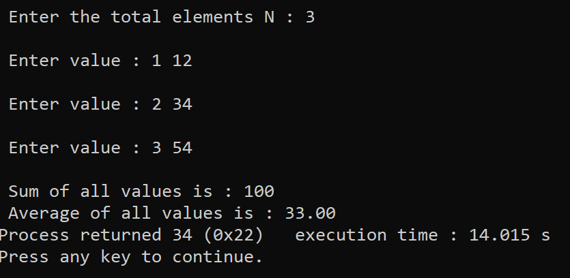

Program 1: Print “Hello World”

#include <stdio.h>
int main()
{
printf("Hello World");
return 0;
}
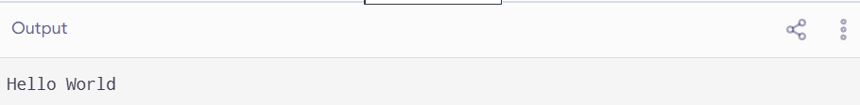
Program 2: Write a Program that takes 2 Values from user and Perform All Arithmetic Operation.

#include <stdio.h>

int main()
{
int a, b;

printf("Enter two numbers: ");
scanf("%d %d", &a, &b);
printf("Addition = %d\n", a + b);
printf("Subtraction = %d\n", a - b);
printf("Multiplication = %d\n", a * b);

if (b != 0)
{
printf("Division = %.2f\n", (float)a / b);
printf("Modulus = %d\n", a % b);
}
else
{
printf("Division and modulus not possible");
}

return 0;
}
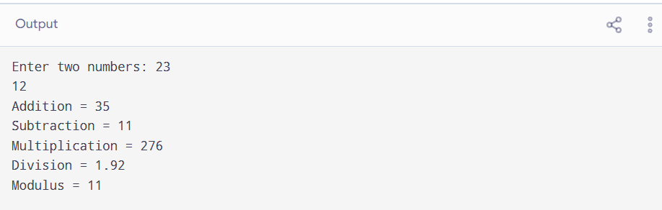
Program 3: Write a program that takes 3 values for Principle Amount, Rate of Interest and No. of Years and find out Simple Interest.
#include <stdio.h>
int main()
{
float p, r, t, si;
printf("Enter Principal Amount: ");
scanf("%f", &p);
printf("Enter Rate of Interest: ");
scanf("%f", &r);
printf("Enter Number of Years: ");
scanf("%f", &t);
si = (p * r * t) / 100;
printf("Simple Interest = %.2f", si);

return 0;
}
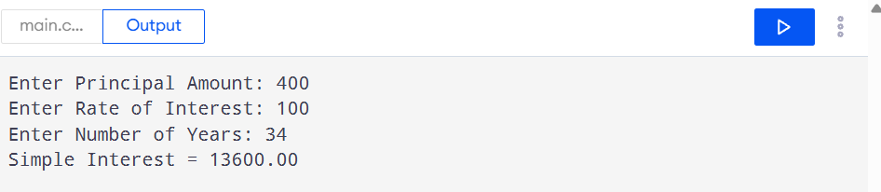
Program 4: Write a Program that input value from user and find out Area of Circle.

#include <stdio.h>

int main()
{
float radius, area;

printf("Enter radius of circle: ");
scanf("%f", &radius);

area = 3.14 * radius * radius;

printf("Area of Circle = %.2f", area);

return 0;
}
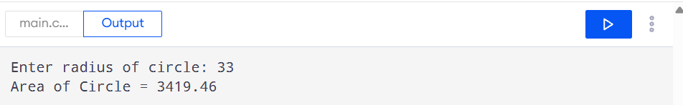

Program 5: Write a Program that inputs two values from the user and finds out the Area of Rectangle.

#include <stdio.h>

int main()
{
float length, breadth, area;

printf("Enter length: ");
scanf("%f", &length);

printf("Enter breadth: ");
scanf("%f", &breadth);

area = length * breadth;

printf("Area of Rectangle = %.2f", area);

return 0;
}
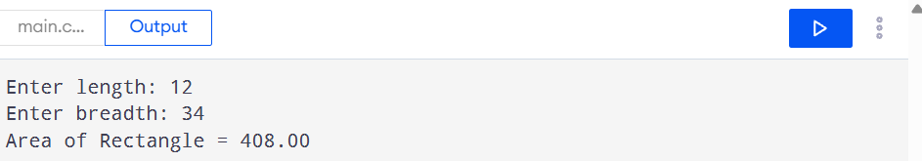

Program 6: Write a program that takes 3 values and finds out their Average.
#include <stdio.h>
int main()
{
float a, b, c, average;
printf("Enter first number: ");
scanf("%f", &a);
printf("Enter second number: ");
scanf("%f", &b);
printf("Enter third number: ");
scanf("%f", &c);
average = (a + b + c) / 3;
printf("Average = %.2f", average);
return 0;
}
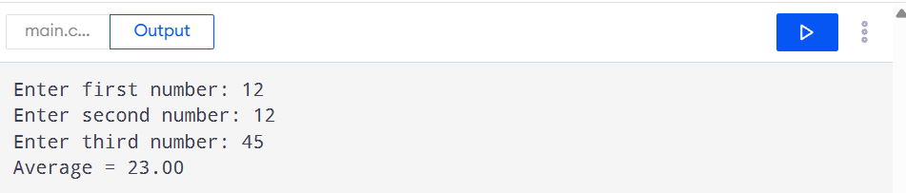

Program 7: Write a program to calculate the Square and Cube of a number.

#include <stdio.h>

int main()
{
int n, square, cube;

printf("Enter a number: ");
scanf("%d", &n);

square = n * n;
cube = n * n * n;

printf("Square = %d\n", square);
printf("Cube = %d", cube);

return 0;
}
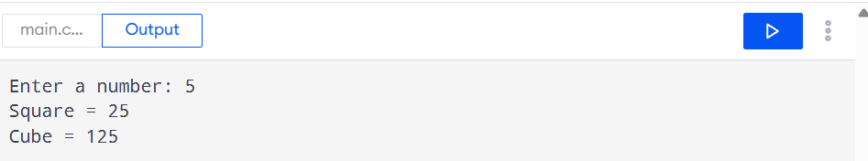

Program 8: Write a program to interchange two numbers using a third variable.
#include <stdio.h>
int main()
{
int a, b, temp;
printf("Enter first number: ");
scanf("%d", &a);
printf("Enter second number: ");
scanf("%d", &b);
temp = a;
a = b;
b = temp;
printf("After interchange:\n");
printf("First number = %d\n", a);
printf("Second number = %d", b);
return 0;
}
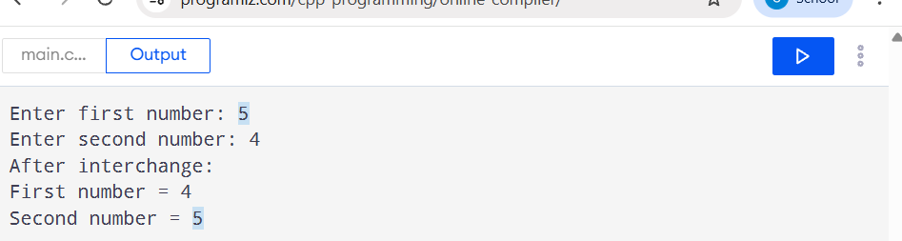

Program 9: Write a program to interchange two numbers without using a third variable.
#include <stdio.h>
int main()
{
int a, b;
printf("Enter first number: ");
scanf("%d", &a);
printf("Enter second number: ");
scanf("%d", &b);
a = a + b;
b = a - b;
a = a - b;
printf("After interchange:\n");
printf("First number = %d\n", a);
printf("Second number = %d", b);

return 0;
}
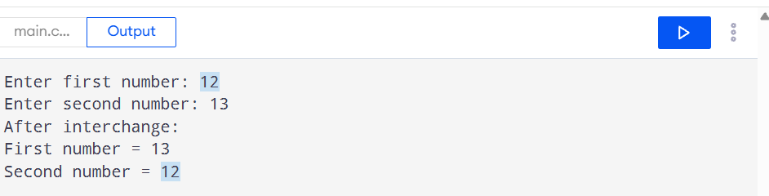

Program 10: Write a program that inputs quantity, price and discount, and displays the final amount.
#include <stdio.h>
int main()
{
float quantity, price, discount;
float total, discountAmount, finalAmount;
printf("Enter quantity: ");
scanf("%f", &quantity);
printf("Enter price per item: ");
scanf("%f", &price);
printf("Enter discount percentage: ");
scanf("%f", &discount);
total = quantity * price;
discountAmount = (total * discount) / 100;
finalAmount = total - discountAmount;
printf("Total Amount = %.2f\n", total);
printf("Discount Amount = %.2f\n", discountAmount);
printf("Final Amount = %.2f", finalAmount);
return 0;
}
